WBS
Project: Pixel Pulse. – Launch of a digital magazine dedicated to retro gaming and hardware preservation.
Main Objective: To publish the inaugural 50-page digital issue and launch the accompanying web platform with a searchable hardware database.

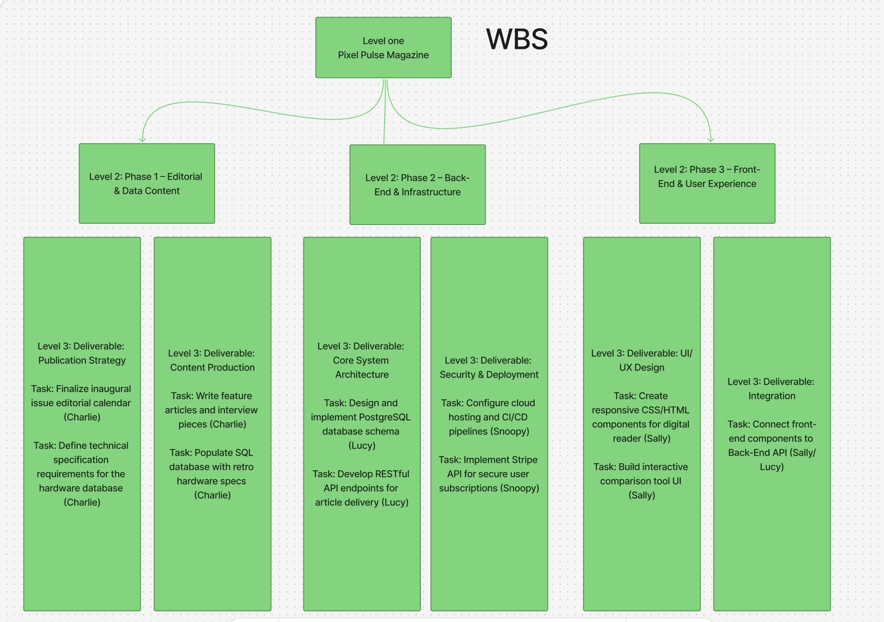

The WBS chart is based on components, separating the main project into three levels and then three sub levels, based on the three main components: Content, Back end and front end. To minimize downtime Charlie builds the content while Snoopy and Lucy build the home where the conent lives (The back end). The most important milestone is the schema sign off in Phase two, which allows data entry to start. The other major milestone is the API and UI connect allowing live data to be seen between both parts.

Task | Assignee | Duration | Start | End | Dependencies
Editorial Calendar | Charlie | 1 Week | Week 1 | Week 1 | None
DB Schema Design | Lucy | 1 Week | Week 1 | Week 1 | None
Cloud Environment | Snoopy | 1 Week | Week 1 | Week 1 | None
Article Writing | Charlie | 3 Weeks | Week 2 | Week 4 | Editorial Calendar
API Development | Lucy | 3 Weeks | Week 2 | Week 4 | DB Schema
UI Component Build | Sally | 3 Weeks | Week 2 | Week 4 | None
Tech Spec Data Entry | Charlie | 2 Weeks | Week 5 | Week 6 | API Dev
Subscription Setup | Snoopy | 2 Weeks | Week 5 | Week 6 | Cloud Env
API/UI Integration | Sally | 2 Weeks | Week 6 | Week 7 | API Dev, UI Build
Final Launch/QA | All | 1 Week | Week 8 | Week 8 | All Tasks

The Gnatt chart is built around the API development and the Database Schema as the most critical point in development, this does lead to a bit of a crunch between weeks 2 and 4 as a lot of the content is being built in parallel. This is because if there is a delay in the API and schema it would prevent content from being added by Charlie or having the UI built by Sally. The dev ops of cloud environment is built early to allow our dev ops engineer, Snoopy, to move on to payment setup.

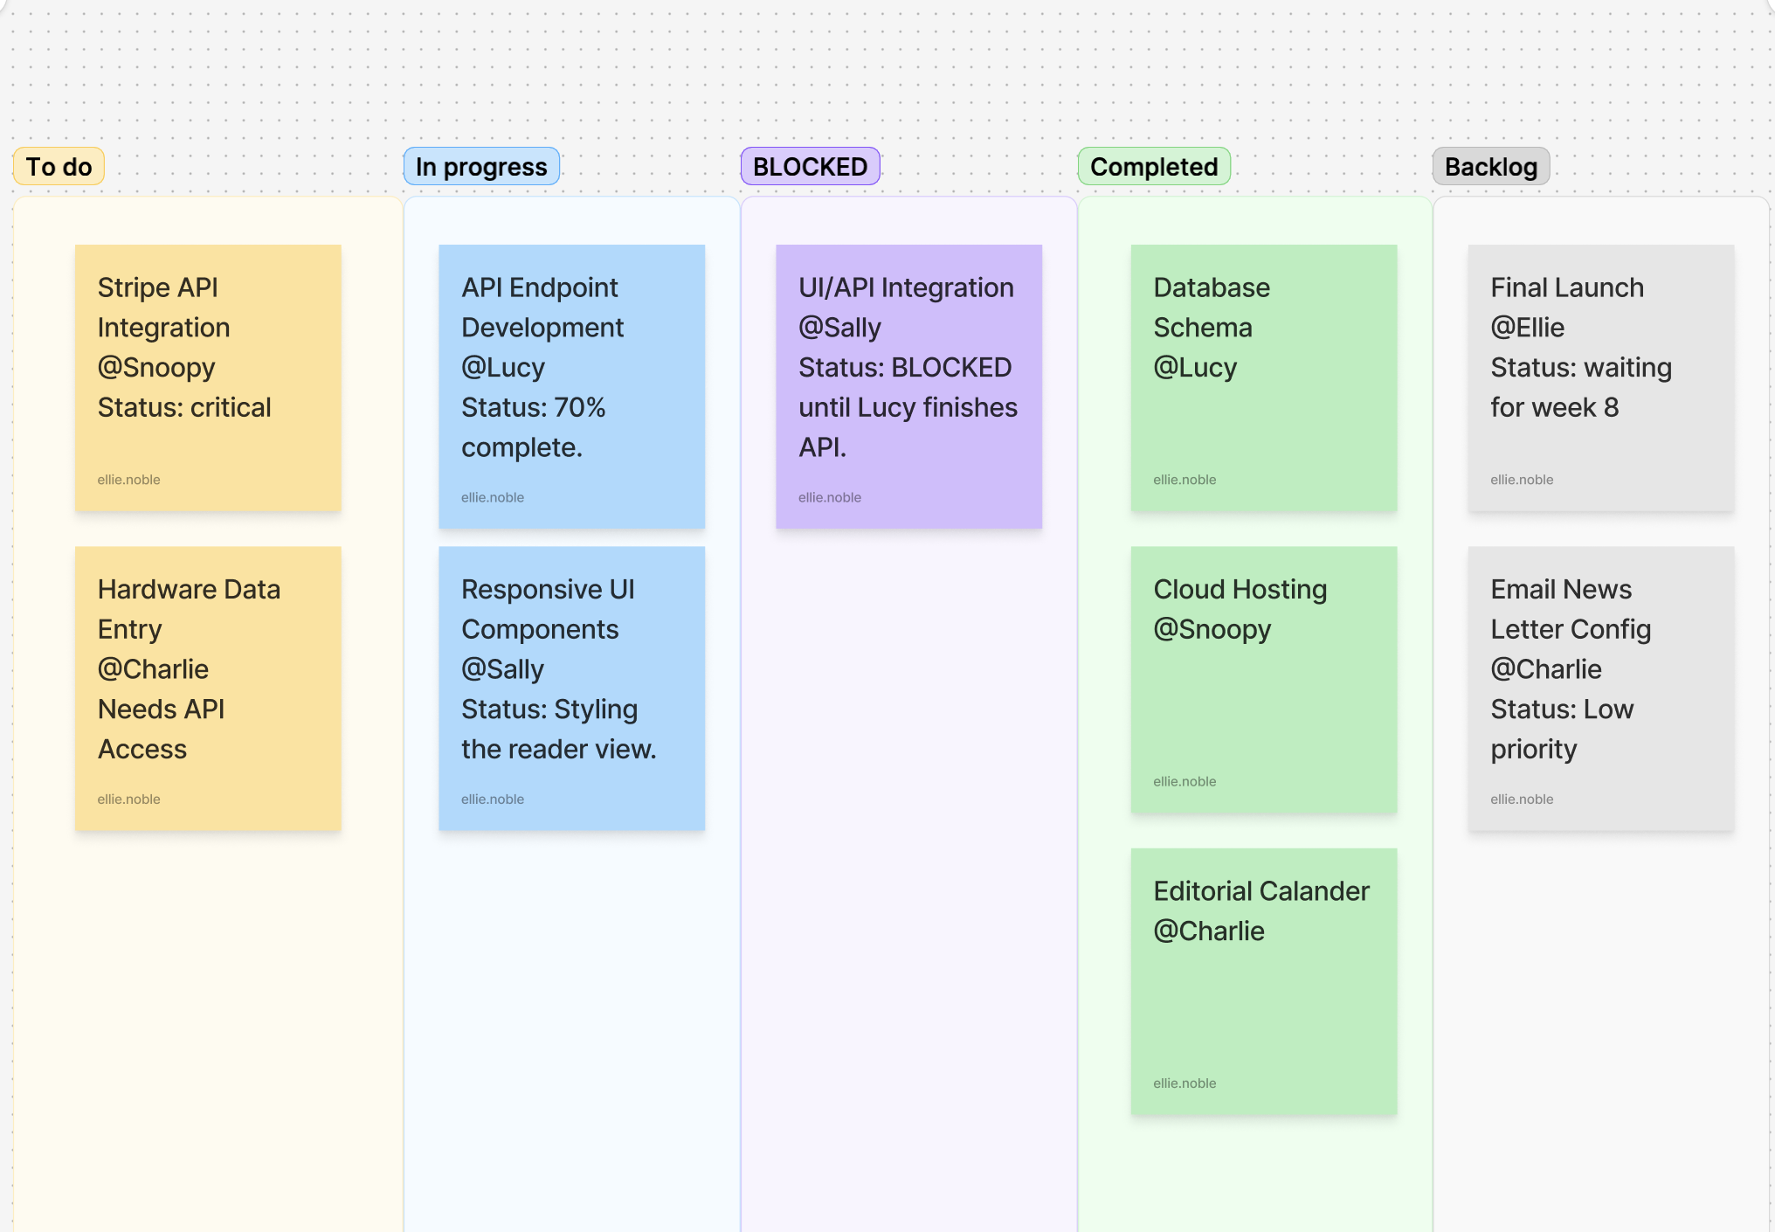

The Kaban board shows a moment of where the website is at a specific point. In this point you can see that everything is moving forward, while the backlog is set for further along. This does show the main blocked area being the API being able to be intirgrated to the UI. The API is a huge backbone of this project, but that does give Sally (Front end) the ability to keep working on the styling of the reader.

